**GREP ASSIGNMENT**

1. Use any .c file. Using grep command extract and display

a. all lines beginning with #include with line numbers

**Ans:**

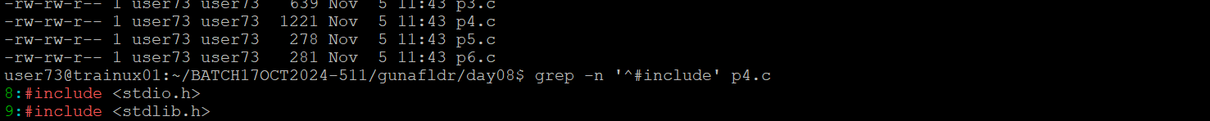

b. display all lines which do not begin with #include

**Ans:**

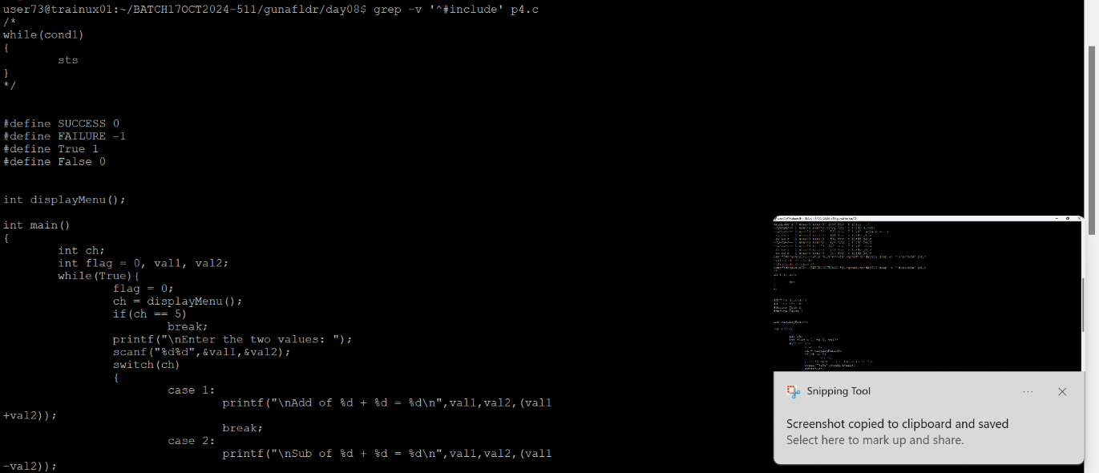

c. display the line number of main()

**Ans:**

d. extract all lines containing characters of opening and closing parathesis {(,))

**Ans:**

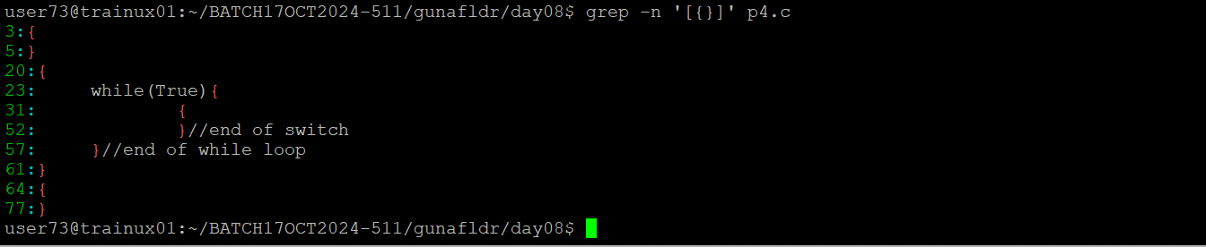

2. Perform the above operations on a set of *.c files

**Ans:**



